PHYS 212 PreLab 5 Name ______________ ID_____________________
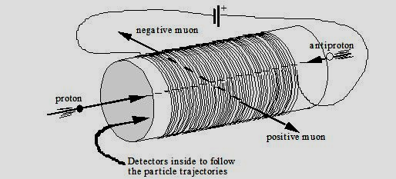
Figure 1. A particle detector
Consider the solenoid as wound in Figure 1. Answer the following questions.
Q1[10’] What is the direction of the magnetic field inside the solenoid? Draw a big fat arrow directly on Figure 1 indicating the direction of the magnetic field inside the solenoid.

Q2[2’] The proton enters the detector along its axis from the left in Figure 1. Does the magnetic field exert a force on the proton?
___________________________________________________________
___________________________________________________________
___________________________________________________________

Q3[2’] The antiproton enters the detector along its axis from the right in Figure 1. Does the magnetic field exert a force on the antiproton?
___________________________________________________________
___________________________________________________________
___________________________________________________________

Consider the oppositely charged muons (remember that a muon is a heavy version of the electron) that emerge from the sides of the detector after the collision. An end-on view is shown in Figure 2, with the proton beam coming out of the page. The outgoing muons are drawn straight as if no magnetic field affected them (the solenoid is not turned on).
Q4[6’] When the solenoid is turned on, which direction (into or out of the page) does the magnetic field point? Indicate this direction directly on Figure 2.

Q5[20’] Sketch the actual trajectories of the positive and negative muons in Figure 2 for the case where there is a strong magnetic field in the direction indicated in your answer above. Note that your sketch should show the trajectories both inside and outside of the solenoid.

direction of
current in coils
negative muon's
direction if no
field is present
positive muon's direction if no
field is present
The proton is coming out of the page at you.
Figure 2. Beam line view of solenoid

Q6[8’] The large CDF (Collider Detector Facility) at Fermilab features a solenoid 3 m in diameter, 5 m long having 1164 turns of superconducting cable. The central field is 1.4 x 104 G. Given this data, what current is running through the coil?

Icoil = __________ [A]

Q7[2’] What length of superconducting cable is used to wind this solenoid?

Lcoil = __________ [m]

